Oneconsole AD group details
Currently there are 4 production apps available in Ctrix Receiver for oneconsole,
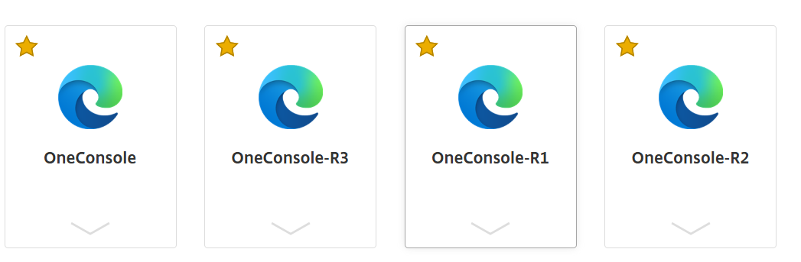
ALL the above applications are mapped to the main group: WW-CTX Oneconsole
below are the groups that comes under the above group,

AT-CTX Oneconsole, BE-CTX Oneconsole, BG-CTX Oneconsole, BR-CTX Oneconsole, CH-CTX Oneconsole, CL-CTX Oneconsole, CO-CTX Oneconsole, DK-CTX Oneconsole, DZ-CTX Oneconsole, EE-CTX Oneconsole, FI-CTX Oneconsole, GR-CTX Oneconsole, HQ-CTX Oneconsole, HR-CTX Oneconsole, HU-CTX Oneconsole, IN-CTX Oneconsole, LT-CTX Oneconsole, LU-CTX Oneconsole, LV-CTX Oneconsole, MA-CTX Oneconsole, MX-CTX Oneconsole, MY-CTX Oneconsole, NL-CTX Oneconsole, NO-CTX Oneconsole, PE-CTX Oneconsole, PL-CTX Oneconsole, PT-CTX Oneconsole, RO-CTX Oneconsole, RS-CTX Oneconsole, SE-CTX Oneconsole, SI-CTX Oneconsole, TR-CTX Oneconsole.

The attached execel file contains the existing AFS group details that we suppose to map the above groups by creating the new groups for separate environment and assign the newly created groups to the respective environment groups.

Quick action:
Connect with the Citrix team to assign the respective country AD groups to one console r1, r2 and r3 and remove these groups from the existing r0.

